AEROPLANE GENERAL DESCRIPTION
(Example document for LSA applicants – v1 17.02.16)

Date of issue: DD/MM/YYYY
Document reference: ABCD-GD-01-00

 | Approval data
 | Prepared by | Verified by | Approved by
Name, sign.
Function | Design Engineer |  | Design Manager

Record of Revision
Rev. # | Issue date | Description of change
0 |  | Initial issue

Introduction
This document describes the main features and gives a general description of the ABCD aircraft for Type Certificate application by XXX Aviation LLC. The requirements are referenced in the compliance checklist of the certification programme ABCD-CP-00.
NOTICE
The aim of this document is to provide an example of an Aeroplane General Description document for an aircraft type certificate application in accordance with CS-LSA.
This document is intended to assist applicants in applying for an LSA RTC/TC and therefore demonstrating compliance of the design to the requirements but it does not substitute, in any of its parts, the prescriptions of Part-21 and its amendments.
The document should not be read as a template and it should not be used as a form to fill. The final content of the document is under responsibility of the user.
The required information can be presented entirely in this document, or in additional documents appropriately identified and referred to.
Comments and notes to the user are provided throughout the document with “blue highlighted and italic text”.
IMPORTANT: All the statements and/or conclusions provided in this guideline can be considered realistic and have a reasonable technical basis but the designer is solely responsible of each of the statements that he/she will provide

Contents
0. Introduction 2
1. References 4
2. Basic description 4
2.1. Wing 4
2.2. Fuselage 4
2.3. Seats 4
2.4. Tailplane 4
2.5. Flight surfaces and controls 4
2.6. Landing gear and brakes 4
2.7. Engine and propeller 5
2.8. Electrical system 6
2.9. Heat and ventilation 6
3. Avionic system 7
3.1. Instrument panel 7
3.2. Avionics layout 8
4. Operational conditions 10
4.1. Weight and balance data 10
4.2. Centre of gravity envelope: 10
4.3. Speeds 10
5. 3 view drawing 11

References
(This section should describe the references to support the description of the type. It normally includes drawings, master data list, etc. A reference to the certification programme should also be provided.)
- Drawing list, ref. no. 123
- Certification Programme ABCD-CP-00

Basic description
The ABCD airplane is a single (piston) engine, single-pilot, two-seated, low-wing all-metal airplane with side-by-side configuration of the seats. The airplane’s structure is of conventional metal construction. Most of the parts are made in Aluminum AL 2024, of different temper and treatment. Some steel parts are also used as described below. The engine compartment is separated from the crew compartment by a steel firewall.

Wing
Wings is made with AL 2024 Aluminum and consists of two half-wings connected to the fuselage with four bolts. The wing is of a trapezoidal plan (with straight Leading edge) and a double-spar design (with main spar carrying most of the bending), ailerons, electrically operated flaps and with integral fuel tanks in the leading edge. The flaps are operated by an electrical switch on the instrument panel.

Fuselage
Fuselage is made with AL 2024 Aluminum. Semi-monocoque structure, consists of frames and sheets reinforced by stringers. It hosts the supports of the flight controls which are interfaced by means of angulars and reinforcements. Most of the avionics equipment are installed in the back of the control panel.

Seats
Two seats are provided with headrests, vertical adjustment, backrest recline and four-point seat belts.

Tailplane
The classical empennage consists of a vertical tail surface and a horizontal tail surface with right and left elevators interconnected by the control transmission. The vertical tail surface of a trapeze shape consists of a vertical stabilizer and a rudder.

Flight surfaces and controls
The flight surfaces consist of conventional ailerons, elevator, and rudder. Ailerons and elevator are deflected through push rods, while the rudder is controlled by steel cables. There is only one elevator trim. The elevator trim and wing flaps are electrically actuated.

Landing gear and brakes
The nose gear is of castoring type (not steerable), and consists of a tubular steel leg connected to the lower engine mount attachments and is fitted with a hydraulic shock absorber.
The main landing gear system consists of two leaf spring steel struts, wheels with disk brakes, and the wheel fairings which are part of the standard equipment.
The struts absorb the landing shocks and are made of quenched and tempered steel. Two wheels 6.00-6 for main landing gear and 5.00-5 wheel for nose are installed.
Hydraulic operated brake discs are installed on the aluminum wheels. Wheel brakes are operated individually using the brake pedals either on the pilot or the co-pilot’s side. The parking-brake lever is located on the centre panel, and closes the return valve of the brake lines.

Engine and propeller
The aircraft is equipped with a Rotax 912 ULS 2 engine (not type certificated), which is of a four cycle, four cylinder horizontally opposed configuration. The cylinder heads are cooled by liquid while the cylinders are cooled by ram air flow.
Engine rotation is clockwise, looking from the pilot’s seat. The performance of the engine is 100 HP at maximum take-off power (limited to 5 min.), maximum continuous power is 90 HP, at 2400 RPM.
Engine output is transferred to the fixed pitch, 1700 mm diameters two-bladed composite propeller (model XYZ-0101 with TC EASA. EASA.P.XXX) using a reduction gearbox (with integrated overload clutch). The reduction ratio is 1:2.43. The engine is controlled with a single lever, located between the two seats.
The basic particulars of the engine are shown here:
Discipline | Value
Maximum power rating | 73.5 kW
RPM @ max power | 2500
Cruise power rating | 69.0 kW @ 2400 rpm
Bore | 84 mm
Stroke | 61 mm
Displacement | 1352 cm3
Compression ratio | 10.5: 1
Firing order | 1-4-2-3
Table 1 – Engine data

Electrical system
Primary DC power is provided by an external alternator with a 14 VDC output, rated of 25 Amps @ 2500 rpm. During normal operations, it recharges the battery. The alternator provides sufficient voltage output above 1200 rpm.
Figure 1 – Electrical power schematic diagram
The alternator and the battery are connected to the battery bus in order to energize the electrical system.
Secondary DC power is provided by a lead type battery (Insert battery type here) which provides the energy necessary for feeding the essential electrical loads in the event of the alternator failure.
For ground starting, external power socket is provided. Each electrical fed instrument is connected to a circuit breaker.
All the electric cables installed to the instrument panel comply with the MIL-C-27500 standards.

Heat and ventilation
The ventilation system features one vent outlet for each occupant. The heating system is provided to warm the cabin and through defrost manifold prevents the windshield from fogging.

Avionic system
The aircraft has a semi-conventional instrumentation, intended for Day-VFR operation. The conventional “sixpack” is replaced with an EFIS display on the pilot side, and contains the necessary flight data and engine data. The display has controls for the remote-controlled VHF radio and NAV radio including VOR/ILS, GNSS.
The instrument panel is divided into five sections: LH, centre, RH, instrument panel cover, and centre console. The EFIS display is located on the LH section together with the analogue indicators for airspeed and altitude. The stack for radio, transponder, navigation and GPS are located on the centre panel. Engine analogue instruments are located to the right.
The GPS antenna is located on the upper side of the fuselage. The COM antenna is located on the top of the vertical stabilizer. The NAV antenna is located underside of the fuselage.
The pitot-static tube is located on the left wing. The magnetometer is located inside of the left wing.

Instrument panel
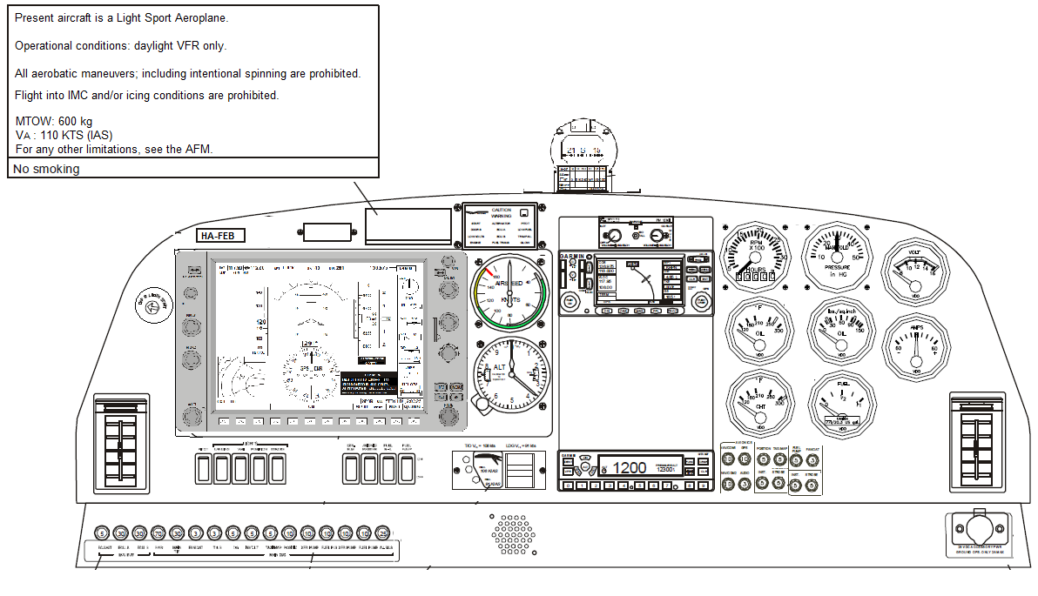
Figure 2 – Instrument panel layout

Avionics layout
PFD/MFD
Integrated with:
– AHRS
– Engine I/O
– Air Data Computer
– Integrated Avionics Unit (VHF COM/NAV/
GPS)
Analog sensor inputs:
– RPM
– CHT
– OT
– Oil press.
– Voltage / amperes
– Fuel qty.
– Manifold press.
Audio Panel

Magnetometer

COM/NAV

Transponder

Pitot head (dynamic press.)
Secondary instruments
ASI
ALT
Static Port

Figure 3 – Avionics system

NOTE: To avoid conflicts with the trademark owners there are mock type designators
Pitot-static instruments
Instrument type | Manufacturer, Type | ETSO/TSO standards
Air speed indicator | Airspeed 01 | ETSO C2d
Altimeter | Alt 10 000 – 3 | ETSO C10b

Radios
Instrument type | Manufacturer, Type | ETSO/TSO standards
COM/NAV radio and GPS (remote) | GPS-COM 400 | ETSO 2C34f, 2C36f, 2C37e, 2C38e 2C40c and C129a
Transponder (remote) | XPNDR 123 | ETSO C112
Intercom | IC 2000
Other instruments
Instrument type | Manufacturer, Type | ETSO/TSO standards
AOA indicator | AOA 001 | ETSO C54
EFIS | G3XXX | N/A
Compass | Where am I 01 | SAE AS 398A
Engine instruments
Instrument type | Manufacturer, Type | ETSO/TSO standards
CHT indicator | CHT 001 | N/A
Oil pressure indicator | OP 0001 | N/A
Oil temperature indicator | OTI 123 | N/A
Voltmeter | VM 12345 | N/A
Fuel quantity indicator | FQI 678 | N/A
Ammeter | AM 1234 | N/A
Manifold pressure indicator | MPI 456 | N/A
RPM indicator | Revol 001 | N/A

Operational conditions
The aircraft will be approved for VFR-DAY operations only.

Weight and balance data
BEM: 360 kg | MTOM: 600 kg | MLM: 600 kg
MZFM: 600 kg | Max. bagg. cap: 20 kg | Max. seat load: 107 kg
Datum plane: a plane through the leading edge at wing mean aerodynamic chord, perpendicular to the longitudinal axis of the aircraft.

Centre of gravity envelope:
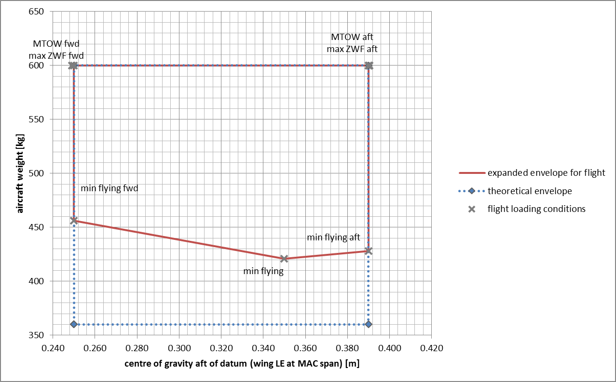
Figure 4 – Weight and balance envelope

Speeds
VNE: 144 KTS | VA: 100 KTS | VS1: 50 KTS
VNO: 120 KTS | VFE: 90 KTS | VS0: 44 KTS

3 view drawing
Wingspan: 10 780 mm
Length: 7165 mm
Height: 2100 mm
Wheelbase: 1750 mm
Wheel track: 1900 mm
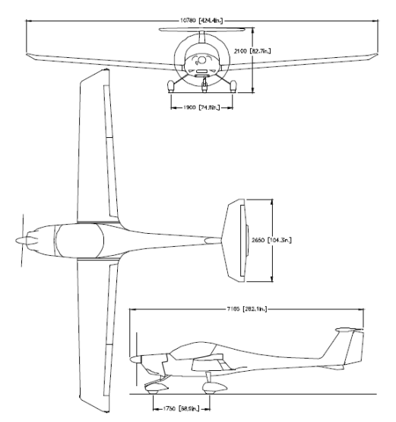
Figure 5 – 3D View

